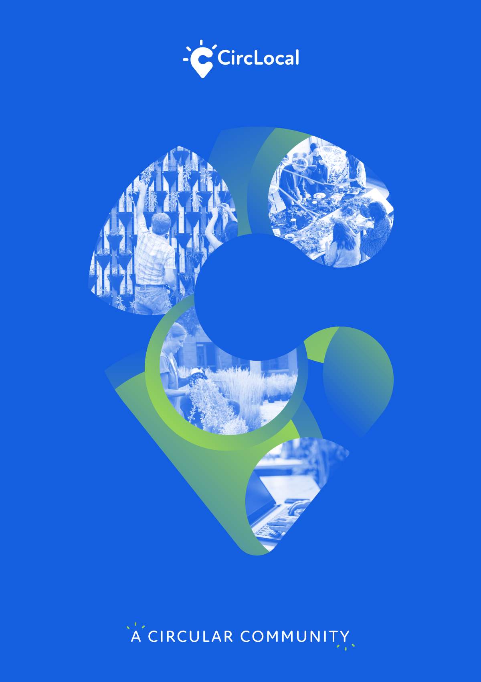

BEST PRACTICES REPORT  
Community S

JULY  
2021

CircLocal Good Practice

|  |  |
| --- | --- |
| 1. Author Contact Information | |
| Name | Maria Semedo |
| Email | msemedo@cleanwatts.energy |
| Telephone |  |

|  |  |
| --- | --- |
| 2. Organization Information | |
| Country | Portugal |
| Region | Coimbra |
| City | Coimbra |
| Organisation Name | Virtual Power Solutions – a Cleanwatts Co. |

|  |  |  |
| --- | --- | --- |
| 3. Organisation in charge of the good practice | | |
| Is your organisation the main institution in charge of this good practice? | Yes | |
| If no, please tell us who is the main institution in charge | Name Organisation |  |
| Country |  |
| Region |  |
| City |  |

|  |  |
| --- | --- |
| 4. General Information | |
| Practice Image |  |
| Title of the practice | Community S demonstration project |
| Geographical scope of the good practice* | Local |

|  |  |
| --- | --- |
| 5. Good Practice Detailed Information | |
| Short summary of the practice | The first P2P energy sharing initiative to be trialled in Portugal under real-life settings and real market conditions in 3 different pilots (Alfândega da Fé, Penela and Lordelo/Vila Real). Hence, it played a fundamental role in consolidating insights and fomenting discussions around this concept in the Portuguese energy landscape, pushing forward the deregulation of these activities in the country. |
| Detailed information on the practice | The Community S demonstration project was the first P2P energy sharing initiative to be trialled in Portugal under real-life settings and real market conditions in 3 different pilots (Alfândega da Fé, Penela and Lordelo/Vila Real). Hence, it played a fundamental role in consolidating insights and fomenting discussions around this concept in the Portuguese energy landscape, pushing forward the deregulation of these activities in the country. This project was scrutinised through a novel business model perspective; an end-user engagement perspective; and a social values-based perspective.  Each pilot in the Community S project represented a low-voltage renewable energy community composed of 4 public buildings equipped with photovoltaic (PV) panels (i.e., prosumers) and on average 41 participating resident citizens10 (i.e., consumers) that were selected by convenience sampling [23]. The core idea behind the proposed business model was the equitable distribution of surplus renewable generation from public buildings among the participating citizens (instead of injecting it in the distribution grid as per business as usual), in addition to facilitating energy efficiency measures [22]. Nonetheless, given that this demonstration project was conducted between 2016 – 2018,11 the P2P energy sharing interactions had to be demonstrated through financial simulations rather than through physical electricity trading per se [22]. In this sense, participating citizens benefited from the advantages of P2P energy sharing by receiving monthly discounts in their energy bills that were equivalent to the costs savings that they would have gotten from the purchase of surplus renewable generation in a desirable deregulated scenario [22].  The benefits from participating in the Community S project were only realised due to the real-time monitoring and control of energy consumption and renewable generation in each participating building (i.e., public buildings and households). Each participant received a smart energy management system to optimise their energy consumption based on the availability of distributed surplus generation within their low-voltage renewable energy community. Hence, in practical terms, participants were asked to keep their smart energy management equipment fully operational during the trial period as to provide consistent data for the simulations of the proposed P2P energy sharing activities.  In terms of broad social goals, the underlying expectations of the Community S project stem back to raising awareness of the next generation of smart energy citizens and incentivise collective participation and cooperation, thus promoting long-lasting community-wide benefits that go beyond the qualitative realms of energy efficiency gains. |
| Resources needed | The Community S project (also known as NetEffiCity - Virtual Power Networks Efficient Management, project no. 18015 under call no. 31/SI/2015 SI I&DT) was co-funded by the Portugal 2020 Programme under the Operational Programme for Competitiveness and Internationalisation (COMPETE 2020), and by the European Union under the European Regional Development Fund (FEDER).  Overall budget: 711,737 € |
| Timescale (start/end date) | 09/2016 - 08/2018 |
| Evidence of success (results achieved) | Development of an innovative approach for the collaborative use of the surplus electricity generation from photovoltaic systems between end-users under the same low voltage/medium voltage transformer substation, which resulted in direct financial benefits to them.  Design and validation of a novel end-user engagement framework constructed around the P2P energy sharing context. Findings based on a sample of 123 participants suggest that the proposed framework was effective in raising awareness and empowering unmotivated, passive end-users in an initial phase of the project implementation, as well as in retaining the interest of motivated end-users during a later phase. Furthermore, the empirical analysis allowed to conclude that participation in the project was predominantly voluntary rather than coerced.  Design and validation of the first overarching social values-based assessment framework that allows the identification of underlying social values associated with these models. The social values enacted in this study were mainly categorised as existing social values that were reinforced by peer-to-peer energy sharing. This framework is scalable, provided that result interpretations undergo a cohesive validity check on a case-by-case basis. |
| Challenges encountered (optional) | No existing regulatory framework on P2P energy sharing at the time of the implementation of the project |
| Potential for learning or transfer | From the business model perspective, as future work, additional sources of distributed renewable generation other than solar energy could be considered, as well as the use of batteries (either automotive or stationary) for optimisation of supply & demand within each P2P energy sharing community. Additionally, this study highlighted that an additional variable could be considered in a renewed NAT (referring to a security of supply insurance), since that the P2P energy sharing communities would still be connected to these higher voltage levels as a means to provide security of supply in case of shortages within the low voltage grid level. This represents a reasonable recommendation especially considering that the margin of the proposed NAT reduction in this study is fairly wide (ranging from 22.1% to 56.4%).  From the end-user engagement perspective, focus should be given on the implementation of the proposed end-user engagement framework under different circumstances (considering for that matter other viable P2P energy sharing business models, legal frameworks, socio-economic backgrounds, geographic locations, pilot scales, end-user segments, etc.) as to produce a wider breadth of results that can be compared to the findings presented in this paper. Ideally, the proposed framework should be trialled out in countries where the P2P energy sharing concept is already deregulated to lessen the level of abstraction of this concept and consequently deepen the engagement of end-users. Also, this paper hypothesises that the proposed end-user engagement framework could be potentially beneficial when set within a wider context of social innovation (e.g., in the broader  context of the sharing economy), since when end-users are more aware of their proactive roles in socioenvironmental innovations, and when those chronically indifferent end-users are identified and  removed right away, the end results become optimised.  From the social values perspective, in terms of scalability, this practice recommends applying the proposed methodological approach in different P2P energy sharing initiatives,32 provided that the result interpretations drawn here are put in perspective and validated through a cohesive validity check on a case-by-case basis. In conclusion, this paper expects to open new pathways to better comprehend the nuances of the social values-based dimension of peer-to-peer energy sharing systems, as well as create a new social values-based language that is explicitly associated with P2P energy sharing. |
| Further information | <https://www.mdpi.com/1996-1073/13/1/125/htm>  <https://www.sciencedirect.com/science/article/pii/S2666188821000022>  https://www.sciencedirect.com/science/article/abs/pii/S0360544220311087 |
| Keywords related to your practice | Peer-to-peer energy trading  Energy sharing  End-user engagement  End-user centricity  Energy community |