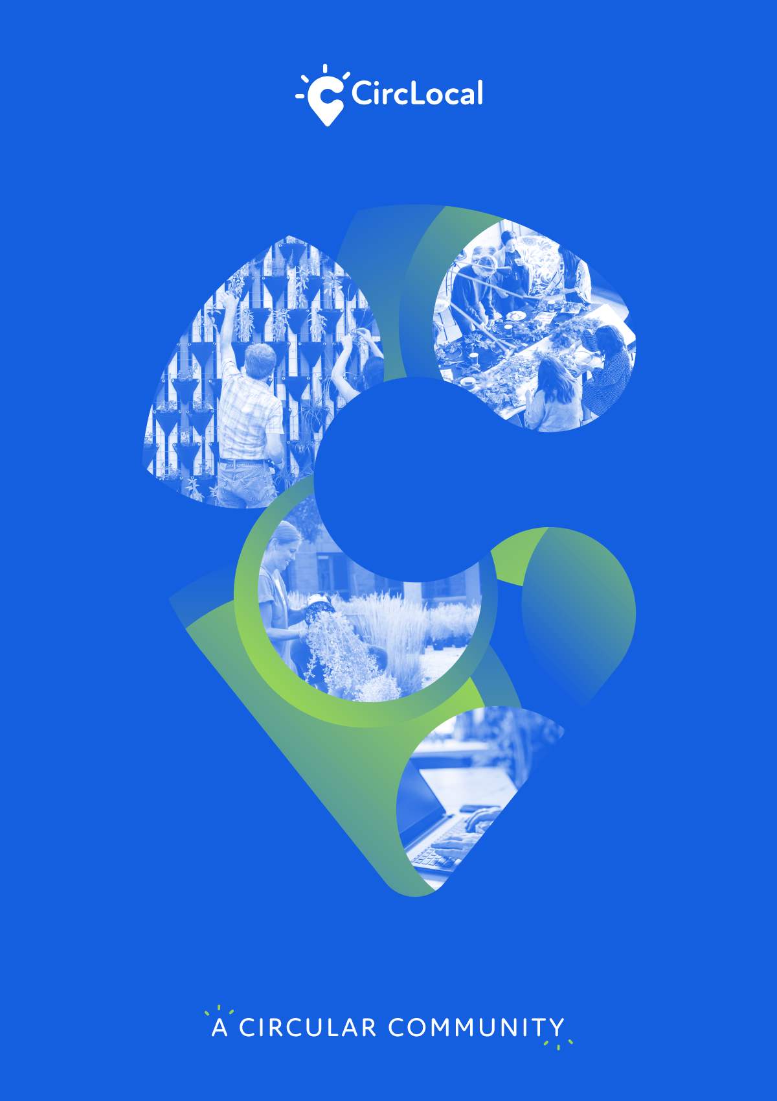
BEST PRACTICES REPORT
Circular+ “Enhancing the Public Procurement in the Coimbra Region”

JULY
2021
CircLocal Good Practice
1. Author Contact Information
Name | Paula Silvestre, Vera Lopes
Email | geral@cim-regiaodecoimbra.pt
Telephone | +351 239795200

2. Organization Information
Country | Portugal
Region | Centro
City | Coimbra
Organisation Name | Comunidade Intermunicipal da Região de Coimbra

3. Organisation in charge of the good practice
Is your organisation the main institution in charge of this good practice? | Yes
If no, please tell us who is the main institution in charge | Name Organisation
 | Country
 | Region
 | City

4. General Information
Practice Image | 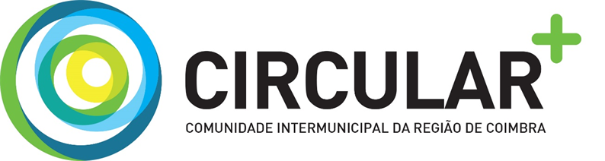
Title of the practice | Circular + “Enhancing Public Procurement in the Coimbra Region”
Geographical scope of the good practice | Regional – NUT III – Coimbra Region which comprises the following municipalities: Arganil, Cantanhede, Coimbra, Condeixa, Figueira da Foz, Góis, Lousã, Mealhada, Mira, Miranda do Corvo, Montemor-o-Velho, Mortágua, Oliveira do Hospital, Pampilhosa da Serra, Penacova, Penela, Soure, Tábua e Vila Nova de Poiares.

5. Good Practice Detailed Information
Short summary of the practice | The aim of Circular + was to acquire skills and knowledge in the circular economy that would allow CIM Região de Coimbra and its member municipalities to create a critical mass of knowledge to promote and foster best practices in this area.
Detailed information on the practice | This project was developed through Purchasing Centre of the CIM Região de Coimbra, and comprised several activities: Training actions, Promotion and Dissemination, Elaboration of framework agreements, Elaboration of Minutes for Municipalities, Drafting of circularity criteria and the Development of online tools.  Training actions  Five training actions (2 trainings, 1 benchmarking and 2 workshops) were carried out for the municipalities that make up the CIM Região de Coimbra on green and circular public procurement and aimed at fulfilling the indicator that evaluated the acquisition of training services within the application "Circular Economy in Public Procurement”.  These actions were carried out with the following objectives in mind:  - The importance of the circular economy for society in general and for the municipalities that make up the CIM Região de Coimbra in particular;  - The adoption of circularity criteria for public procurement in future acquisition procedures;  - The dissemination of the individual good practices of each municipality to all the municipalities that make up the CIM Região de Coimbra;  - The introduction of bid evaluation criteria that include factors and sub-factors that include the circular economy;  - The creation of proposal evaluation models that are appropriate to the circular economy, forgetting the criterion of lowest price to the detriment of the most economically advantageous proposal, where factors such as prevention, reduction, reuse, recovery and recycling of materials and energy are evaluated;  - Present the possibilities that the European legislator, through Directive 2014/24/EC, and the national legislator, through Decree-Law No. 111-B/2017, of 31 August, which substantially amended the Public Procurement Code, have enshrined for the application of the circular economy in procurement procedures (environmental and social criteria, reservation of contracts, etc.).  Promotion and Dissemination  Within the scope of the activity for promotion and dissemination three types of tasks achieved: the creation of a brand identifying the circular economy actions of the Coimbra Region CIM, a circular public procurement manual and multimedia contents that resulted in the making of an animation film, with an original script.  Elaboration of framework agreements  The pieces of two public tenders were prepared and approved for the conclusion of framework agreements for the selection of suppliers for the provision of services and supply of hygiene and cleaning consumables and another for the selection of suppliers of convergent services for mobile voice and data and voice and data at a fixed location, which include criteria related to the circular economy, for the 19 (nineteen) municipalities that integrate the CIM Região de Coimbra to have necessarily and compulsorily to implement these criteria in the procedures that they launch under these framework agreements.  These two framework agreements made by the Purchasing Centre of the CIM Região de Coimbra were discussed by the 19 municipalities, which were able to give their contributions.  This is the best way to involve all municipalities and raise their awareness to make their purchases through these framework agreements. These 2 framework agreements with circularity criteria are a way to improve the efficiency of the tenders that include the application of the criteria regarding the circular economy and green purchasing. The option taken was that of open framework agreements, i.e. they are signed with various operators, which allows the 19 municipalities and other entities that are part of the Purchasing Centre of the CIM Região de Coimbra (municipal companies, IPSS, etc.), to make their awards without the need to repeat the entire tendering process. It is the CIM Região de Coimbra understanding that framework agreements contribute to the promotion of the circular economy as they allow for greater flexibility in the awarding of contracts and, in some cases, bring together demand from a number of authorities or over time. They can also increase incentives for suppliers to offer better solutions from an environmental point of view, given the potential to award multiple contracts and therefore recover the additional costs arising from the implementation of these solutions.  Elaboration of Drafts for Municipalities  Elaboration of prior consultations drafts, being these the purchasing procedures for recourse to framework agreements, so that the 19 municipalities that integrate the CIM Região de Coimbra can easily use the framework agreements concluded by the Purchasing Centre of the CIM Região de Coimbra in their acquisitions regarding convergent mobile voice and data services and voice and data at a fixed location and the provision of services and supply of hygiene and cleaning consumables. Thus, in addition to the ease of use of framework agreements, it also provides the standardization of procedures within the CIM Região de Coimbra, which facilitates the submission of proposals by co-contractors of framework agreements and especially makes all municipalities implement the requirements on circular economy that were set in the framework agreements.  Drafting of circularity criteria  In the two public tenders for the conclusion of framework agreements for the selection of suppliers of convergent mobile voice and data and fixed location voice and data services and the provision of hygiene and cleaning consumables, circularity criteria were introduced, which included economic, social and environmental criteria.  Criteria of mandatory application were defined, i.e. those which are not subject to competition and their violation legally imply the exclusion of the proposal, as well as adjudication criteria, i.e. those which allow the valorisation of the proposals.  Circularity criteria were also defined for application in prior consultation procedures for acquisitions using framework agreements.  Development of online tools  A set of tools was developed, to be integrated in the portal of the Purchasing Centre of the CIM Região de Coimbra, that can be used by the 19 municipalities that integrate it and that are the vehicle to promote and sustain green and circular public procurement in the region, namely:  - Supplier evaluation tool;  - Tool for preliminary consultation;  - Tool for archiving and restoring qualification documents;  - Good practice forum tool;  - Negotiation tool:  - Dynamic negotiation module in catalogue format;  - Bidding module;  - Auctions module.
Resources needed | Financial Resources: 62 036,43 €
Timescale (start/end date) | 21th August 2018 to 30th November 2018
Evidence of success (results achieved) | - Training for the municipalities that make up the CIM Região de Coimbra on green and circular public procurement;  - Within the scope of the Coimbra Region CIM Região de Coimbra’s Purchasing Central Office, the pieces for opening public tenders were prepared and published in the OJEU for the signing of two framework agreements, one for the selection of suppliers for the provision of services and supply of hygiene and cleaning consumables and the other for the selection of suppliers of convergent mobile voice and data and fixed location voice and data services, where there are criteria related to circular economy, which implies that the 19 (nineteen) municipalities that integrate the CIM Região de Coimbra must necessarily and obligatorily implement these criteria in the procedures that they launch under the scope of these framework agreements;  - Use of the framework agreements of CIM Região de Coimbra as the best tool for the dissemination of the circular economy, being its application recommended to the 19 (nineteen) municipalities of CIM Região de Coimbra, as well as to the other entities that integrate the Purchasing Centre of CIM Região de Coimbra, namely municipal companies, Private Institution of Social Solidarity, etc.;  - The door has been opened to contracting external consultancy services to assist in the preparation of technical specifications for public tenders published in the Official Journal of the European Union for the conclusion of a framework agreement, where circular economy components are introduced, which may or may not be subject to competition, assisting the jury in evaluating the proposals, particularly with regard to compliance with the circular economy characteristics;  - Improving the efficiency of tenders that include the application of circular economy and green procurement criteria through the conclusion of framework agreements. These can be concluded with one or several operators and allow the awarding of several contracts without the need to repeat the whole tendering process;  - The drafting for the 19 municipalities that make up the CIM Região de Coimbra was aimed at standardising procedures, facilitating the presentation of proposals on circular economy matters for the co-contractors of the framework agreements and obliging contracting authorities to implement the criteria on circular economy and green procurement;  - The actions carried out within the scope of this application focused on the system-oriented circularity model, notwithstanding identifiable concerns at supplier level;  - Awareness-raising of managers and technicians of the 19 (nineteen) municipalities that make up the CIM Região de Coimbra on the importance that Circular Economy has for the country and in particular for the Coimbra Region.
Challenges encountered (optional) | The aim of the project was to acquire skills and knowledge in the circular economy that would enable CIM Região de Coimbra and its member municipalities to create a critical mass of knowledge to promote and foster best practices in this area.  The step taken here, although not the first in terms of environmental protection is crucial for this entire region to get on the circularity and eco-sustainability train, remaining at the forefront in this chapter and effectively contributing to the advancement of the country.  The circular economy issue is a matter of culture, way of thinking and coherence of action. It is reductive to evaluate the success of a project in this area with mathematical indicators, with numbers. The true evaluation will be made through the ability to change behaviours and ways of acting and thinking of an entire generation. Until we get there, until we are able to evaluate the future of what has just started, several actions have been identified, already listed above, which, through their implementation, may give guarantees that we are on the right track and heading towards the intended change in behaviours and ways of thinking. We are starting a cultural shock, with the difficulties that all new things bring, but with the strength of the certainty that this path is not an option but a necessity.
Potential for learning or transfer | Some key factors of Circular + initiative can contribute for easy replication across other regions:  - It was created circular economy good practices manual that will surely be very useful in the purchases that CIM Região de Coimbra and the 19 municipalities that integrate it will make. This manual is easy to read and very intuitive which allows its easy dissemination;  - Even small contracting authorities, with limited workforce dedicated to public procurement, can be champions for circular procurement if they receive support.
Further information | https://www.cim-regiaodecoimbra.pt/cim-rc/projeto-circular-potenciar-as-compras-publicas-na-cim-regiao-de-coimbra/
Keywords related to your practice | Circular public procurement; strategic public procurement; learning & sharing community.

