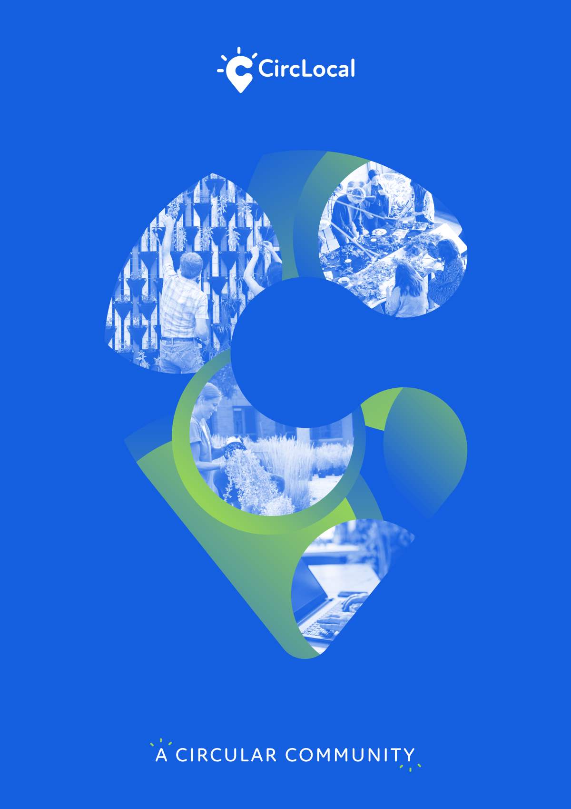
BEST PRACTICES REPORT
Centro Green Deal
JULY
2021
CircLocal Good Practice

1. Author Contact Information
Name | Ana Pires
Email | ana.pires@ccdrc.pt
Telephone | +351 239400146

2. Organization Information
Country | Portugal
Region | Centro
City | Coimbra
Organisation Name | CCDRC - Comissão de Coordenação e Desenvolvimento Regional do Centro

3. Organisation in charge of the good practice
Is your organisation the main institution in charge of this good practice? | Yes
If no, please tell us who is the main institution in charge | Name Organisation
 | Country
 | Region
 | City

4. General Information
Practice Image | 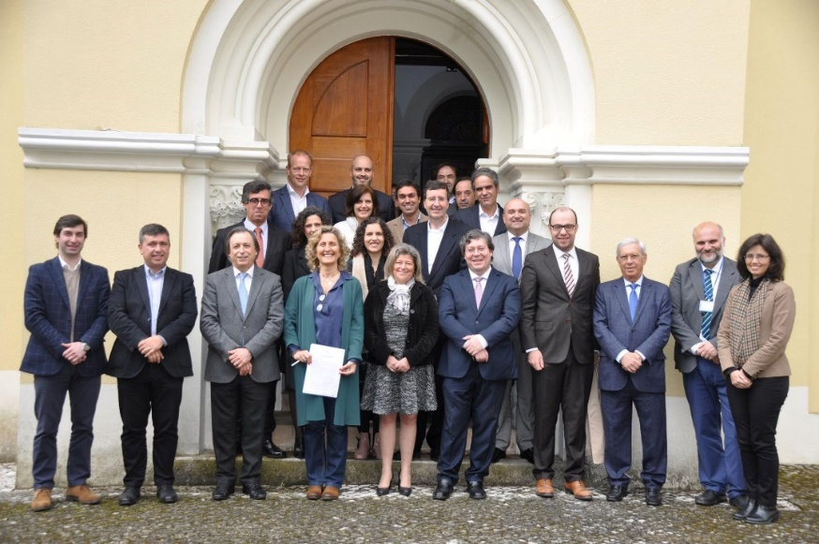  Members of the Centro Green Deal Network shortly after signing their letter of commitment on the 8th of April, 2019
Title of the practice | Centro Green Deal: Circular Public Procurement
Geographical scope of the good practice* | Regional

5. Good Practice Detailed Information
Short summary of the practice | The Centro Green Deal initiative (Centro GD) is a pilot that has the goal of introducing circular principles in public procurement through the promotion of a learning and sharing community.
Detailed information on the practice | Centro Region has an Agenda in place to foster the transition of the Region to circular economy. One of the main axis of the Agenda is circular procurement, a powerful tool to promote this transition through applying circular principles in current public tenders.  Inspired by the Dutch Green Deal on Circular Procurement, the Centro GD was adapted to address the Region’s specificities and the exemplary role of public entities for the strategic use of public procurement.  Like in the Dutch model, each participating entity has to launch, at least 2 circular tenders, and share all the knowledge gathered in this process with all participants, contributing to a sharing and learning community.  This initiative is coordinated by CCDRC and has 12 participating public entities:  - 3 Municipalities  - 5 Intermunicipal Associations  - 2 Polytechnic Schools  - 1 University  - 1 Hospital  The constitution of a Monitoring Group involving 7 national entities with responsibilities/projects related with public procurement is another dimension of this initiative. This multilevel articulation is important, not only because our is a region in a centralised country, but also because the benefits are two-fold: the project benefits from the knowledge and the leverage of these entities, and in turn, they also can benefit from the project’s ground work.  The Centro GD working process was supported through the organisation of regular meetings to ensure the engagement of all participants and workshops/technical sessions addressed to identified challenges and participants needs. Synergies with two other initiatives were promoted within which these workshops were delivered:  - DG Regio pilot action on Strategic use of Public Procurement  - UE Training Course on GPP  Recently, a Portuguese version of the book “Circular Procurement in 8 steps” (https://circulareconomy.europa.eu/platform/en/toolkits-guidelines/circular-procurement-8-steps) was launched, being available for download in the webpage of the project.
Resources needed | No significant financial resources were required to set up this pilot. This initiative relies mainly on human resources integrating the circular economy team of CCDRC.
Timescale (start/end date) | 2018 - ongoing
Evidence of success (results achieved) | The results show that important changes were made in the way acquisition procedures are conducted. Aiming to more sustainability and circularity in procurement is now a cherished norm for the participating entities.  Up to now, we have had 14 tenders with circular principles launched.  Among the launched procedures, we highlight the purchase of reusable/recyclable products, the acquisition of services over goods, the favouring of freshness, seasonality and proximity when purchasing food products, the acquisition of electric vehicles and the acquisition of construction materials integrating construction and demolition waste.
Challenges encountered (optional) | The greatest challenge is a shift in the mindset, starting by the way the need to be addressed is formulated.  Adopting circular principles can be perceived as a risk or as harbouring higher costs.  Learning by practice is necessary since the majority of the circular solutions are tailor made, requiring time and dedication.  Capacity building activities work best when technicians and decision makers from the same organisation have the opportunity to learn together.
Potential for learning or transfer | Some key factors of Centro GD initiative can contribute for easy replication across other regions:  - To launch such an initiative one does not have to be an expert in circular procurement (or in procurement in general), since the key role of the coordinator is to make sure the network is alive, to orchestrate it, to mobilize expertise and promote a continuous learning and sharing process;  - Being ‘just’ a learning and sharing community can be a rather cheap project;  - Even small contracting authorities, with limited workforce dedicated to public procurement, can be champions for circular procurement if they receive support;  - A strategic approach to public procurement can boost circular economy. It can be embedded in other local, regional and national policies (like climate change strategy, energy transition, S4, etc.), guaranteeing a significant contribution to promoting the efficient use and productivity of resources.
Further information | http://agendacircular.ccdrc.pt/centro-green-deal/  https://s3platform.jrc.ec.europa.eu/en-US/web/guest/w/green-deal-on-circular-procurement-in-the-centro-region
Keywords related to your practice | Circular public procurement; strategic public procurement; learning & sharing community.

