BEST PRACTICES REPORT
Raw Materials Flow Analysis
FEV
2021

CircLocal Good Practice

1. Author Contact Information
Name | Ewout Oppers
Email | Ewout.oppers@leeuwarden.nl
Telephone | +316 433 65 175

2. Organization Information
Country | The Netherlands
Region | Friesland
City | Leeuwarden
Organisation Name | Gemeente Leeuwarden

3. Organisation in charge of the good practice
Is your organisation the main institution in charge of this good practice? | Yes
If no, please tell us who is the main institution in charge | Name Organisation
 | Country
 | Region
 | City

4. General Information
Practice Image | 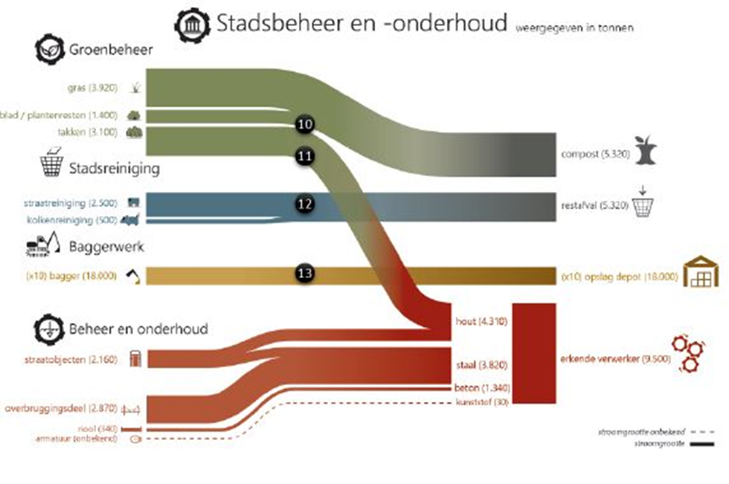
Title of the practice | Raw Material Flow Analysis
Geographical scope of the good practice* | Local

5. Good Practice Detailed Information
Short summary of the practice | The municipality of Leeuwarden has mapped all their raw material flows used in civil engineering and maintenance in a so-called Raw Material Flow Analysis. By doing so, the organisation has a clear image of its largest material flows and the CO2-emissions. Having this information visible, the next step is to set clear targets and to take action on closing the loop for each of these material flows.
Detailed information on the practice | The municipality of Leeuwarden wants to reuse all of its materials, close building material chains and eliminate all waste in the municipality by 2050. Additionally, it wants to maximize its circular procurement by 2025. To make waste streams more efficient, the municipality first had to map the streams of raw materials used in civil engineering and maintance.  The material flow analysis was conducted in cooperation with an external party. The results show there were three main flows in civil engineering:  - Moving soil  - Concrete roads  - Asphalt roads  Regarding maintenance, the municipality had the following main flows:  - Green waste (grass, wood)  - Dredging  - Construction parts  The RMFA showed the municipality the amounts and types of raw materials it had available through everyday activities such as maintaining the public parks (for instance grass) or roads (asphalt and concrete). With this insight, the municipality can redirect the flows so that raw materials can be used for new products or services, instead of being wasted. In this way, the outcomes of the material flow analysis form the foundation for targeted action on closing the loop for the organization of the municipality. It creates awareness on what the impact is of these materials. Moreover, it has an impact on how the city cooperates with its suppliers and partners. To be able to close the loop, more cooperation with local companies and other governments is required. Finally, closing these loops will result in a lower usage of virgin materials, lower CO2-emissions and a more connected network of companies and governments.
Resources needed | The total budget for this project was €20.000,- to map the material flows and provide advice on how to close (some of) the loops. Moreover, 100 hours of internal support was required to deliver the required data.
Timescale (start/end date) | Report was established between November 2018-March 2019. To implement the advice and closing the loops is an ongoing process.
Evidence of success (results achieved) | - Increased awareness on the CO2-emissions and material usage  - At least 5 projects developed from the analysis focusing on closing loops  - Inspired others to do the same  - A new monitor will be released in 2021/2022 that shows the progress
Challenges encountered (optional) | A (communication) plan is required for further implementation after the analysis is delivered. In this way, follow up and support are more guaranteed.
Potential for learning or transfer | To make the next step in a circular economy as a local government, you need to have insights in your output and the material flows you can affect. A material flow analysis of your organisation is therefore a great starting point. It also tells you more about which flow provides the highest impact. After the analysis, the organisation can set priorities and clear targets on how to diminish these material flows. After three of four years measure your circularity again to see the generated impact.
Further information | Material Flow Analysis Leeuwarden (in Dutch)
Keywords related to your practice | Materials, circular economy, municipality, procurement, local government, analysis, infrastructure

